How to docs:
To make changes to the code and pushing it up to Bluemix use these steps.
https://github.com/cloudfoundry/cli/releases

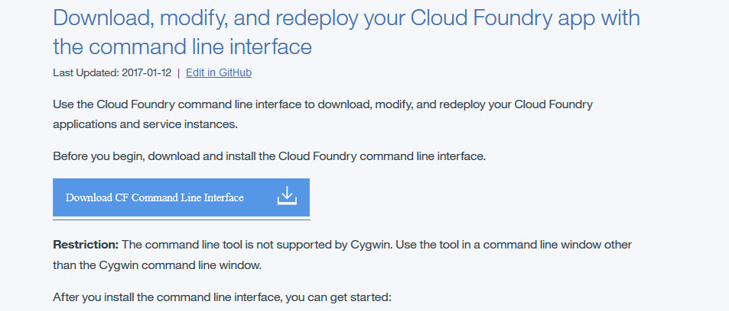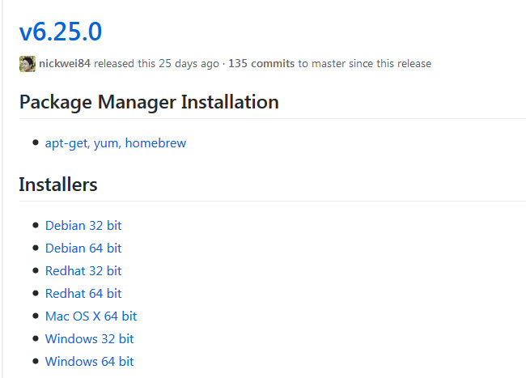

Once you have installed CLI, Go to the Bluemix instance. select the application, then from the left panel select "getting started”.

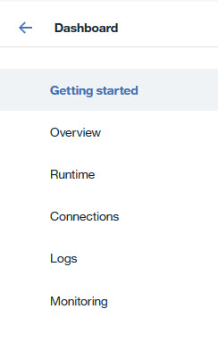

Use the commands below to push the code into Bluemix. Make sure to be in the folder that you are trying to push into the Bluemix.
